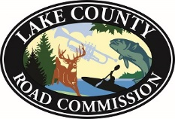
1180 Michigan Avenue
Baldwin, MI 49304
231-745-4666 Fax 231-745-6227
roads@lcrc-roads.com

NOTICE

THE November 10, 2021 and November 24, 2021 MEETINGS OF THE LAKE COUNTY BOARD OF ROAD COMMISSIONERS HAVE BEEN RECHEDULED FOR November 9, 2021 and November 23, 2021.

Jessica LaPointe
Finance & HR Manager May 27, 2021 4:26 pm

